Portfolio Website Project Report
Project Title
Personal Portfolio Website
Introduction
A Portfolio Website is a personal web application designed to showcase an individual's profile, skills, projects, achievements, and contact information. It serves as a digital resume and helps demonstrate web development skills.
Objective
The objective of this project is to create a responsive and visually appealing portfolio website using HTML and CSS that effectively presents personal and professional information.
Technologies Used
- HTML5
- CSS3
- Visual Studio Code
- GitHub
Features
- Responsive design
- About Me section
- Skills showcase
- Projects section
- Contact information
- Modern user interface
Project Structure
- index.html
- style.css
- images/
- README.md

Implementation
HTML was used to structure the content, while CSS was used to style the website and ensure responsiveness across different screen sizes.

Screenshots
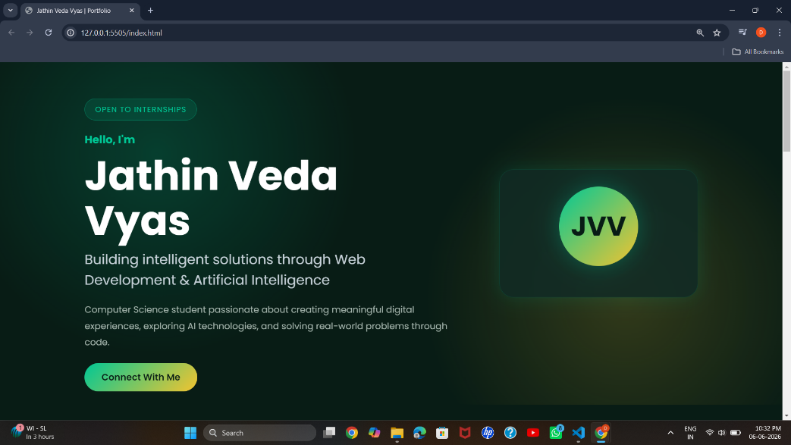
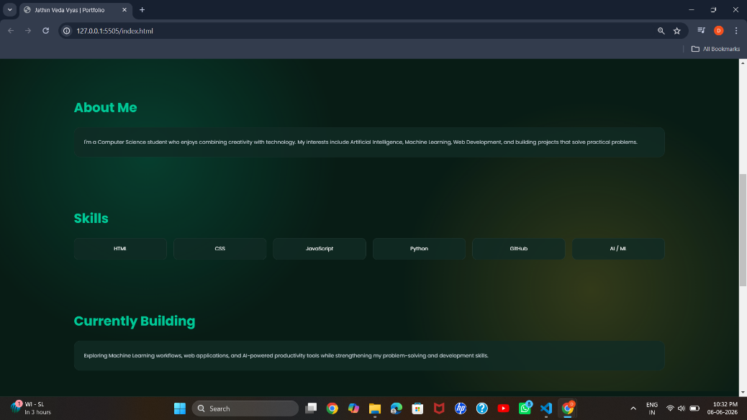
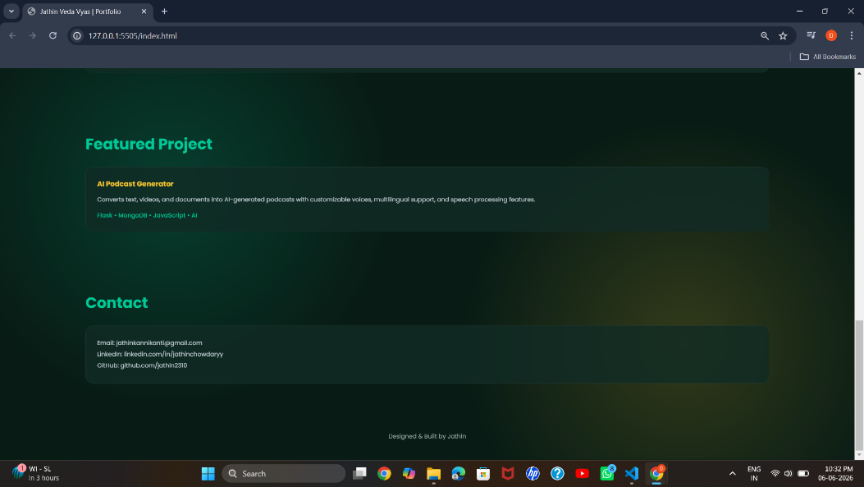

Challenges Faced
- Creating a responsive layout
- Designing an attractive user interface
- Organizing content effectively
Learning Outcomes
- Understanding HTML page structure
- CSS styling techniques
- Responsive web design concepts
- GitHub repository management
Conclusion
The Portfolio Website successfully demonstrates personal information, technical skills, and project experience through a clean and professional interface.

